**Minutes Sheet**

**Meeting 1: 14/10/19 – 15:00 – 15:55**

**Group Members Attending: Jake, Bryony, Ruth, Thomas, Johannes, Ciara**

* A screenshot of a cell phone

  Description automatically generatedCustom design – Garden Maze?
* Discussed relationships and inheritance for both the cell and moveable classes
* Base cell would have x, y coordinates as well as data of what cell is to its NESW positions – Linked list?
* A screenshot of a cell phone

  Description automatically generatedCollectibles/Items are layered on top of the grid? Separate from Cells themselves; Could be stored on User as variables or an array of the items themselves
* 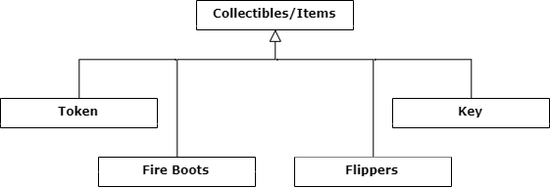Discussed how to save the map: Need base map file?

If so, need to save changes in a separate file as well as the attributes e.g. if a door has been opened at a given position.

Base map file would contain the map layout as well as the positions and states of all movables, collectables and doors

**TODO:**

CRCs and UML for each class discussed

**Jake:** Base cell, Wall, Ground

**Bryony:** Kill, Teleport, Door

**Ruth:** Collectibles/Items

**Ciara:** Moveable, User, Enemy

**Thomas:** Line, Wall, Dumb

**Johannes:** Smart, Goal